Friday 27th March 2020,

Good morning everyone,

We’ve come to the end of the first week of alternative schooling. I hope you’ve had lots of fun learning new thing at home this week and I hope you’ve all been on your best behaviour.

Many thanks to those of you who have been doing my daily challenges, and also those who have been sending work to your teachers. I really enjoy seeing your messages and I promise that I’ll try to respond to them all as soon as I can. Jude, I’m still working on your odd one out challenge!

Today’s challenge is a bit different. There are 2 options (or both if you get bored over the weekend).

Challenge 1 (English): Write a biography of a famous person who you are interested in. It could be anyone at all: a footballer, pop star, TV celebrity, or someone who is famous in history: I’ll give you some examples but you can choose anyone you want. Try to pick someone you don’t already know about so that you learn something new.

Martin Luther King, Mother Theresa, Nelson Mandela, Neil Armstrong, Rosa Parks, Elvis Presley, Wolfgang Amadeus Mozart, Albert Einstein, King Henry VIII, Vincent Van Gogh

Challenge 2 (Art):
Use this link to youtube (https://www.youtube.com/watch?v=iaeuh77zX08) to try and draw a picture of Mickey Mouse. You all know that art is not my strong point but I like to challenge myself so I had a go:

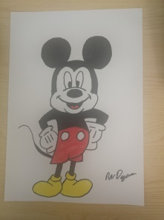

Then take a picture of it and send it to me. There’s lots of other cartoon characters on Youtube if you enjoy this and want to try some others.

Have a great weekend everyone, see you all soon.

Mr Dyson

