Thursday 26th March 2020,

Good morning everyone,

I hope you are all ok and staying fit and healthy. I hope you are also finding lots of time to enjoy the good weather that we are having at the moment. Whilst you are learning from home the teachers and I are also learning new things and hopefully we will be able to share those with you soon.

Many thanks to all of you that are doing the daily challenges; I love reading all your answers. Keep them coming! Keep up the good work, and make sure that you keep helping your parents by being on your best behaviour

Today’s challenge is a tough one, I’ll be interested to see if any of you can solve it.

Mr Dyson’ daily challenge (Maths)

Today I have quite a tough maths challenge for you. It is called the chess board challenge. A chess board has 64 squares:

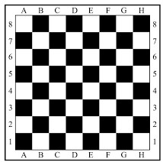

I am going to give you two choices:

Option 1: You can have £1,000,000.
Option 2: You can use the chess board. I will give you 1p on the first square, I will double it on the second square (2p), I will double that again on the 3rd square (4p), again on the 4th square (8p) and so on until all 64 squares are full.

Which option do you choose? Remember, the important bit of this is to explain your reason for your choice.

I look forward to seeing your answers.

Take care everyone,
Mr Dyson

