Year Group | Autumn 1 | Autumn 2 | Spring 1 | Spring 2 | Summer 1 | Summer 2
1 | Our School Ground  (Geography Focus) | Ourselves  (History Focus) | The UK  (Geography Focus) | The Fire of Nantwich  (History Focus) | Toys  (Linked to Literacy Scheme- Pathways)  (History Focus) | The Seaside  (Geography Focus)
2 | The British Isles  (Geography Focus) | The Great Fire of London  (Linked to Literacy Scheme- Pathways)  (History Focus) | The Great Fire of London  (History Focus) | Explorers  (Geography and History Focus) | Our Town  (Geography Focus) | Paddington  (Geography Focus)
3 | The UK  (Geography Focus) | Nantwich  (Geography Focus) | Stone Age  (History Focus) | Stone Age to Iron Age  (History Focus) | Romans (European country focus: Italy)  (Geography Focus) | Romans  (History Focus)
4 | The Vikings and Anglo Saxons  (History Focus) | The Vikings and Anglo Saxons  (History Focus) | Denmark  (Geography Focus) | Cheshire Cheese  (History Focus) | Rainforests  (Linked to Literacy Scheme- Pathways)  (Geography Focus) | Brazil  (Geography Focus)
5 | Victorians  (History Focus) | Mountains  (Geography Focus) | Rivers  (Geography Focus) | Ancient Greece  (History Focus) | Ancient Greece  (History Focus) | Geography Skills  (Geography Focus)
6 | World War II  (History Focus) | World War II  (History Focus) | Asia with a focus on China  (Geography Focus) | Asia with a focus on China  (Geography Focus) | Shang Dynasty  (History Focus) | Our World  (Geography Focus)

Year 1

Our School Grounds (Autumn 1)
- Recognise some similarities and differences of geographical features in my own immediate environment

The UK (Spring 1)
- Understand the concept of the world.
- Understand the UK is an island and is surrounded by the sea.
- Name and locate the 4 countries of the UK.
- Name some of the surrounding seas of the UK.
- Talk about the main features of one of the four countries that make up the UK.
- With support compare their local area with a contrasting area identifying some similarities and differences.
- Identify some human and physical features of their local area, Nantwich.

Seaside (Summer 2)
- Discuss ways of life in the past and how it is similar and different to their own
- Talk about some similarities and differences between ‘now’ and ‘the past’ both within and beyond living memory
- Compare the human and physical features of two British localities (Nantwich and Llandudno) including how the use of land differs in each locality.
- With support, use geographical vocabulary such as beach, coast, forest, hill, mountain, sea, river, weather, city, town, village, factory, farm, house, office shop to refer to the physical and human features of places studied.
- Use some physical and human features such as beach, coast, forest, hill, mountain, sea, river, weather, city, town, village, factory, farm, house, office shop to refer to the physical and human features of the wider local area.
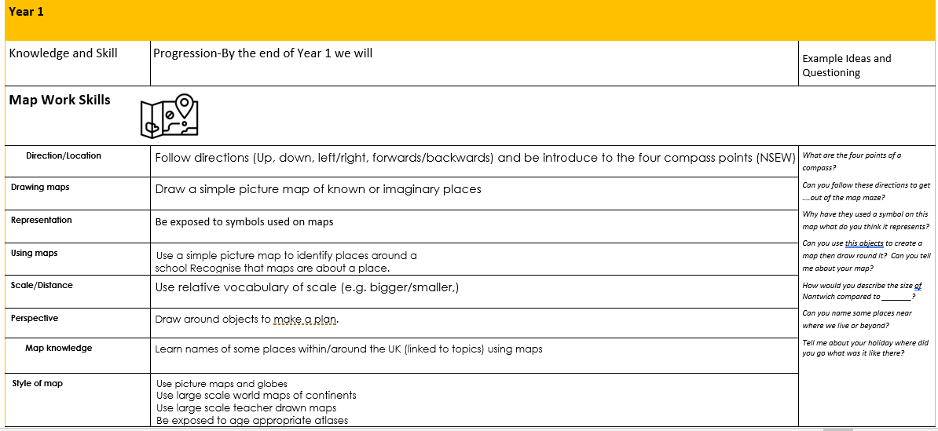
Know about weather in their locality, what happens in different seasons and how weather changes on a daily basis.

Year 2

The British Isles (Autumn 1)
- Name and locate the capital cities of the 4 countries of the UK.
- Name, locate and identify the main characteristics (physical and human) of one the four countries and capital cities of the UK.
- Know the UK is surrounded by sea and name the seas surrounding it.

Explorers (Spring 2)
- Name and locate the 5 oceans and the 7 continents.
- Know that there are hot and cold areas of the world and this is linked to the equator and north and south poles.
- Identify some ‘hot’ and ‘cold’ countries/places and know what it is like there (weather, temperature, plants and animals etc).

Our Town (Summer 1)
- Recognise some similarities and differences of geographical features in two local areas (Delamere and Nantwich).
- Identify some of the key features of a location and whether it is a city, town, village, coastal, urban or rural area.
- Identify human and physical features of their local town, Nantwich, and make comparisons with other places studied (London links to Great Fire of London)
- Identify the physical and human features such as beach, coast, forest, hill, mountain, sea, river, weather, city, town, village, factory, farm, house, office shop to refer to the physical and human features on maps of the wider local area.
- Use geographical vocabulary such as beach, coast, forest, hill, mountain, sea, river, weather, city, town, village, factory, farm, house, office shop to refer to the physical and human features of places studied.

Paddington (Summer 2)
- Compare their local area with a contrasting area Peru (non-European Country) identifying similarities and differences of their physical and human geography.
- Identify human and physical features of their local town, Nantwich, and make comparisons with other places studied
- Know about weather in the UK, what happens in different seasons and how weather changes on a daily basis and collect data linked to weather changes for contrasting areas such as Lima, Peru.
- Use geographical vocabulary such as beach, coast, forest, hill, mountain, sea, river, weather, city, town, village, factory, farm, house, office shop to refer to the physical and human features of places studied.
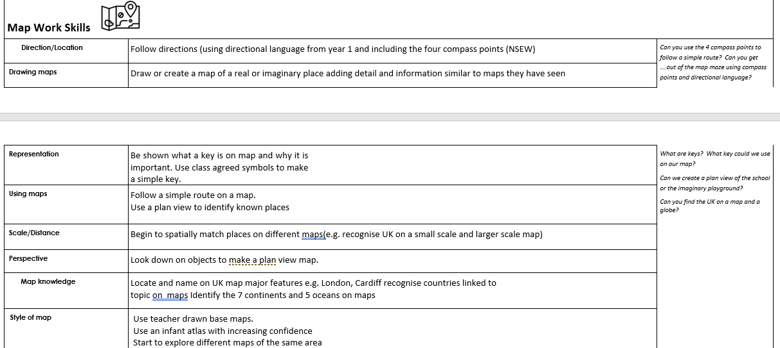

Year 3

The UK (Autumn 1)
- Name and locate cities and counties of the UK.
- Name the geographical regions of the UK
- Understand the human and physical geography of larger area within the United Kingdom (North-West England)
- Understand how land is used in different places and why people choose to settle in different places.

Nantwich (Autumn 2)
- Compare the similarities and differences of physical and human geographical features in a town, city, village or hamlet (Keswick).
- Identify human and physical features of their local town, Nantwich and make comparisons with other places with North-West England (a town in Cumbria, Keswick).
- Identify the geographical similarities and differences between Cheshire and Cumbria.

Italy (Summer 1)
- Identify the position and significance of Equator, Northern Hemisphere and Southern Hemisphere.
- Use maps to locate countries in Europe especially focusing on the countries that border Italy.
- Identify environmental regions, key physical and human characteristics, countries and major cities of places studied within the UK and Italy
- Understand how land is used in different places and why people choose to settle in different places.
- Identify the geographical similarities and differences between Nantwich and Rome.
Year 4

Year 4
Recapping knowledge from Year 3 throughout the year:
- Name and locate cities and counties of the UK.

- Describe and understand the water cycle (Linked to Science)

Denmark (Spring 1)
- Use maps to locate country of Denmark and the surrounding countries around it.
- Identify the position and significance of Equator, Northern Hemisphere and Southern Hemisphere. Where is Denmark in relation to the equator and how does this affect it?
- Identify environmental regions, key physical and human characteristics, countries and major cities of places studied (Copenhagen) within the UK and Europe.
- Compare the similarities and differences of physical and human geographical features in a town, city, village or hamlet.

Rainforests (Summer 1)
- Identify the position and significance of Equator, Northern Hemisphere and Southern Hemisphere.
- Understand how land is used in different places and why people choose to settle in different places.
- Identify human and physical features of the Amazon Rainforest and compared to their own lives.
- To study the impact of human influence on the Amazon Rainforest (Positive and Negative)
- To be able to describe the similarities and differences between Nantwich and the Amazon Rainforest.
- Describe and understand where energy comes from including renewable and non-renewable sources.

Brazil (Summer 2)
- Compare the similarities and differences of physical and human geographical features in a town, city, village or hamlet.
- Understand how land is used in different places and why people choose to settle in different places.
- Identify human and physical features of their local town, Nantwich or North-West England, and make comparisons with other places (Rio De Janerio)
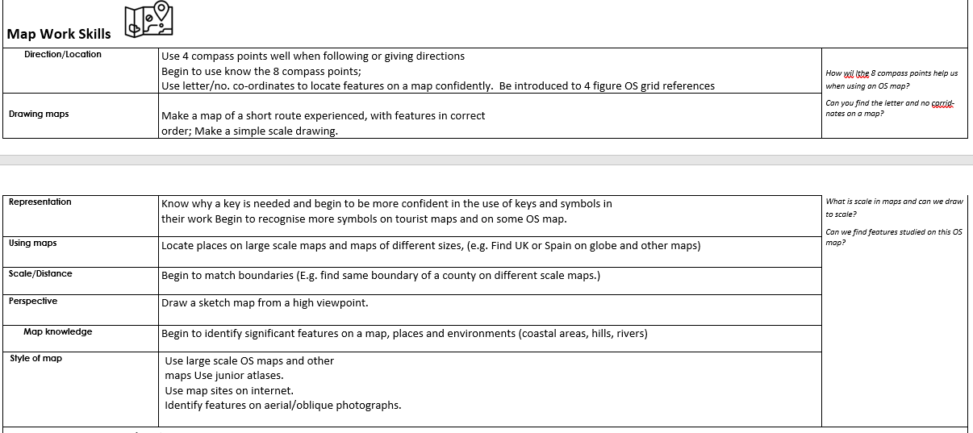
- Identify the position and significance of Equator, Northern Hemisphere and Southern Hemisphere. Where is Brazil in relation to the equator and how does this affect it?

Year 5

Mountains (Autumn 2)
- Name and locate major cities and countries in Europe and North and South America linked to units of work.
- Use a variety of maps to locate and identify geographical regions and physical and human characteristics of countries and places studied.
- Describe and understand mountains and their impact on physical and human geography of an area.

Rivers (Spring 1)
- Name and locate major cities and countries in Europe and North and South America linked to units of work.
- Use a variety of maps to locate and identify geographical regions and physical and human characteristics of countries and places studied.
Describe and understand how and why rivers are formed.
- Describe and understand the different features of a river.

Greece Linked to History Ancient Greece (Summer 1)
- Be able to recognise how places fit within a wider geographical context and are interdependent.
- Describe and understand key aspects of human geography, including, economic activity including trade links.
- Identify the position and significance of latitude, longitude, Equator, Northern Hemisphere and Southern Hemisphere.
- Identify the Prime/Greenwich Meridian and time zones and understand how the location of a place has a different time than ours.

Geography skills (Summer 2)
- Use a variety of maps to locate and identify geographical regions and physical and human characteristics of countries and places studied.
- Name and locate major cities and countries in Europe and North and South America linked to units of work.
- Be able to identify, describe and explain in detail how and why places are similar to / different from other places in the same country or elsewhere in the world
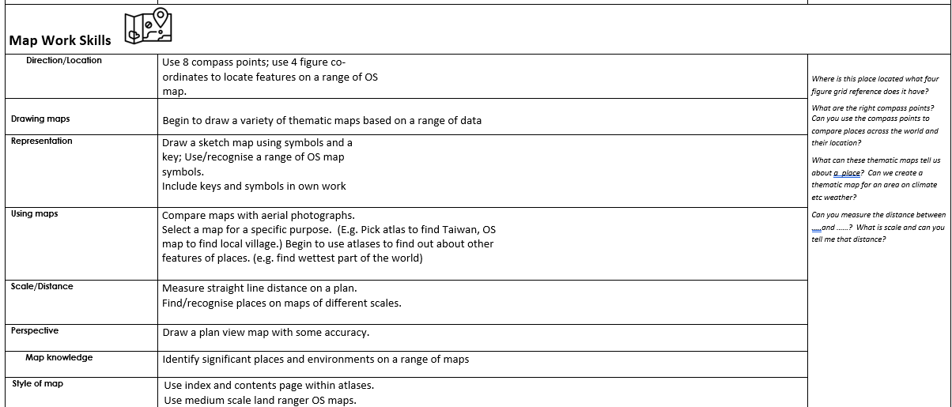

Year 6

Asia with a focus on China (Spring 1 and 2)
- Describe and understand key aspects of human geography, including, economic activity including trade links.
- Describe and understand the impact natural resources– minerals, water, food has on the economic activity of an area.
- Use a variety of maps to locate and identify geographical regions and physical and human characteristics of countries and places studied.
- Understand and explain the use of land.
- Identify the Prime/Greenwich Meridian and time zones and understand how the location of a place has a different time than ours.
- Be able to identify, describe and explain in detail how and why places are similar to / different from other places in the same country or elsewhere in the world

Our World (Summer 2)
Name and locate major cities and countries in Europe and North and South America linked to units of work.
- Describe and understand key aspects of physical geography, including: climate zones, biomes and vegetation belts.
- Describe and understand mountains, volcanoes and earthquakes and their impact on physical and human geography of an area.
- Understand and explain the use of land and why people settle in volatile places.
- Identify the position and significance of latitude, longitude, Equator, Northern Hemisphere and Southern Hemisphere, the Tropics of Cancer and Capricorn, Arctic and Antarctic Circle in relation to places studied.
- Identify the Prime/Greenwich Meridian and time zones and understand how the location of a place has a different time than ours.
- Be able to identify, describe and explain in detail how and why places are similar to / different from other places in the same country or elsewhere in the world
